GST NO : 03AFPFS5226N1ZI
SWASTIK POWERTECH
Sales Office: GT Road, Near City Police Station 1, Khanna, 141401
Distt. Ludhiana, Punjab
Mobile: 98150-01168, 96532-02260
e-mail: powertech.swastik@gmail.com

Our Company LOGO: 

Company Profile:
Swastik Powertech is a forward-thinking energy solutions company dedicated to providing reliable, sustainable, and cost-effective solar power systems for both residential and commercial needs. As a sister concern of the well-established Swastik Distributors, which boasts over a decade of experience in the distribution of industrial transformers and motors, Swastik Powertech carries forward a strong legacy of technical expertise, trust, and customer satisfaction.
With a commitment to driving the transition towards clean energy, Swastik Powertech offers end-to-end solar solutions—from consultation and system design to installation and after sales service. Whether it's powering homes with rooftop solar panels or equipping businesses with large-scale commercial setups, we ensure top-quality products, seamless execution, and long-term support.
Our deep understanding of electrical systems, backed by the industrial strength of our parent company, positions us uniquely in the solar market. We aim not only to reduce energy costs for our clients but also to contribute meaningfully to a greener and more sustainable future.
At Swastik Powertech, we believe the future is solar—and we are here to power it.

Transformers:
- We deal in
- Power Transformers
- Distribution Transformer
- Furnace Duty Transformer
- IDT (Inverter Duty Transformer)
- We have provided upto 40MVA Transformers
- Take some photos of transformers from Google
- Companies we work with: CG(Crompton Greeves), Kirloskar, Nucon, Power Engineers & Consultants, T&R (Transformers & Rectifiers), Voltampp, Mehi Power
- Company Logos
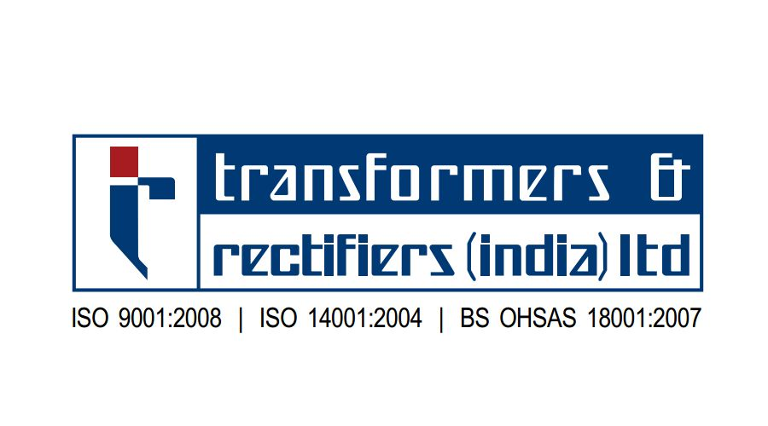



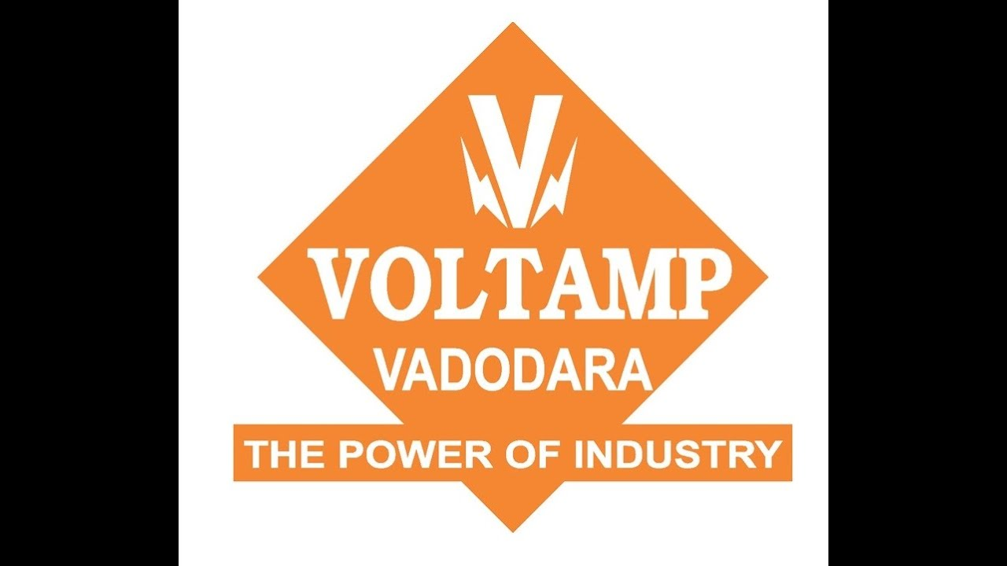

- Our Client:
- Madhav Stelco, Talwara Road Sirhind side, Mandi Gobindgarh, Punjab-147301
- Jogindra Vardhman Group, G.T. Road, Sirhind Side, Mandi Gobindgarh-147301
- Oswal Woolen Mills Ltd, Grand Trunk Rd, Near Sherpur Chowk, Industrial Area C, Sherpur, Ludhiana, Punjab 141003
- RP Multimetals Ltd, Kumbh - Amloh Rd, Mandi Gobindgarh, Punjab 147301
- Bansal Alloys & Metals Pvt Ltd, G.T. Road, Sirhind Side, Mandi Gobindgarh - 147301
- Aarti Steel Inetrnational Ltd, G.T. Road, Miller Ganj, Ludhiana - 141 003
- Arora Iron & Steel Rolling Mills, near Phase 7, Dhandari Khurd, Focal Point, Ludhiana, Gobindgarh, Punjab 141003
- Kisco Castings India Ltd, Guru Ki Nagri, Bhadla Road, Mandi Gobindgarh-Bassi Rd, Mandi Gobindgarh, Punjab 147301
- Gian Casting Pvt Ltd, Mandi Gobindgarh-Bassi Rd, Mandi Gobindgarh, Gobindgarh R, Punjab 147301
- Vital Steel Bars LLP, Vill.Budhewal,Chandigarh Road,Ludhiana -141112
- Dashmesh Castings Pvt Ltd, Jalalpur, Punjab 147301
- Dhiman Steel Rolling Mills, Amloh Rd, Gandhi Nagar, Mandi Gobindgarh, Punjab 147301
- Shri Ambey Steel Industries, Village, Peer Gajju Shah Road, Alaur, Khanna, Punjab 141401
- K.L. Alloys Pvt Ltd, Talwara road, Grand Trunk Rd, Mandi Gobindgarh, Punjab 147301
- Varun Steel Casting Pvt Ltd, Mugal Majra Rd, Mugal Majra, Punjab 141401
- Radhika Steel Industries, RG Mill Rd, Mandi Gobindgarh, Punjab 147301
- PP Casting, VILLAGE KUMBH, Kumbh - Amloh Rd, Mandi Gobindgarh, Punjab 147301
- Samana Concast, Amloh - Mandi Gobindgarh Rd, Turan, Punjab 147301
- Lord Mahaveer Industries Pvt Ltd, Sirhind Side, Grand Trunk Rd, Mandi Gobindgarh, Punjab 147301
- Shree Ganesh Edibles Pvt Ltd, Amloh - Khanna Rd, near village Shahpur, Amloh, Punjab 147301
- Bhushan Pipes, Grand Trunk Rd, Alaur, Mandi Gobindgarh, Khanna, Punjab 141401
- Karam Steel Corporation, Nasrali Rd, Nasrali, Mandi Gobindgarh, Punjab 147301
- Bhawani Castings Pvt Ltd, Ambe Majra, Mandi Gobindgarh, Punjab 147301
- Bassi Alloys Pvt Ltd, near P.S.E.B. Grid, Ambe Majra, Mandi Gobindgarh, Punjab 147301
- Vimal Alloys, GT Road, Sector 3-C, Mandi Gobindgarh, Punjab 147203
- Allied Recylcing Ltd, Budhewal Rd, Budhewal, Punjab 141112
- Chopra Alloys, Bhadla- Kheri Nud Singh Rd, Vill Alour, Khanna, Punjab 141401

Solar:
We are authorised dealers of Havells India Pvt Ltd. For Solar
Comprehensive Solar Solutions
- Design, installation, and maintenance of solar power systems for households, businesses, and industries
- Customized solutions based on energy needs and site assessments
Green Energy Focus
- Promoting clean, renewable, and sustainable energy
- Helping clients reduce carbon footprints and energy bills
High-Quality Components
- Use of tier-1 solar panels, inverters, and batteries
- Partnered with trusted manufacturers for reliability and performance
Future-Ready Technology
- Integration with smart monitoring systems and IoT-enabled energy tracking
- Scalable systems to grow with your power needs
Why Choose Us?
- Trust, transparency, and technical know-how
- Competitive pricing with financing and subsidy support
- Turnkey solar solutions tailored to your needs

Companies we deal in:
- Havells (We are authorised Dealers)
- Saatvik
- Luminous
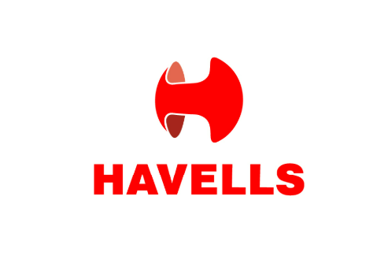
Key Note:
We have installed over 1.4 MW of solar projects in just 8 months of starting our operations and we have another 1MW projects in our pipeline.

Our Clients:
- RKC Infra Projects, Highway, NH-73, Kakkar Majra, Saha, Haryana 134202
- SD Industries, Focal point, near dutt wire, Ajnali, Punjab 147301
- Aggarsain Agro Foods, Khanna - Samrala Rd, Bardhalan, Lalauri, Punjab 141417
- Varun Agro Cold Store, Fatehpur Road, Village Nasrali, Tehsil Khanna, Nasrali Ludhiana, Punjab, 141414
- Garg Rice Mills, Kishanpura Road Dhramkot, Kishanpura Road, Dharamkot, Moga-142042, Punjab
- Garg Nutri Foods, Tehsil Dharamkot, Pandori Araian, Dharamkot, Moga-142042, Punjab, India
- Satkartar Autos, G T Road, Vill. Bullepur, Khanna – 141401
- Minni Ispat, Opposite Railway Station, Mandi Gobindgarh-147301, Punjab, India

